|  |
| --- |
| Food Violations Report |
| Joel Bailey2810ICT Software TechnologiesJanuary 13, 2019 |

# Abstract

Violations committed by stores is an important data set to study and understand. The information within this data set may inform us where it is safe and were it is not safe to buy our goods and services. This report studies the distinctive type of violation committed and how many times that specific violation had been committed between July 2015 and December 2017. The report also studies how many violations are committed by each zip code in California. The resulting data informs us that on average all the zip codes in California commit around 100 violations per Month. These violations are more likely to be in regard to the maintenance and structure of the facility and less likely to be in regard to hygiene and sanitary conditions of the facility.

# Introduction

The purpose of this report is to investigate and compare the trends of food violations across the state of California over the period July 2015 to December 2017. The data has been obtained from two excel work books. The first work book contains information of each inspection that was conducted between the specified period. The second work book provides information on all the violations that had been committed between the specified period. This data will be imported into a database where it can be queried to produce coherent information that can identify specific trends or patterns within the data. This report will focus on the distinctive types of violations and how often they occurred as well as the number of violations committed by each unique zip code. The following two sections of this report will discuss the findings of the queries that were run against the database and identify any common trends or patterns that are found.

## Database Structure

# 

# **Violation counts**

To count the occurrence of each violation code the database was queried for the violation code, violation description and the total amount of times the violation code had appeared in the data. The results where then grouped by the violation code providing, useful information in regard to each distinctive violation code. The results of the query where then stored in an excel spread sheet for future use.

After querying the database, the results showed that the violation which had been committed the most was F044, “Floors, walls and ceilings: properly built, maintained in good repair and clean”. According to our results this violation had been committed 102012 times between the period July 2015 to December 2017. The results also show that the most common occurring violations were related to the maintenance and state of the physical store where as the lowest occurring violations were related to personal hygiene and sanitary conditions present in the store.

During the study of the data it was evident that double entries of data had been made (two or more rows of data that were identical). It was decided to leave these entries in when creating the report as it was not possible to determine if these entries had been made by mistake or if they were legitimate violations that had occurred. This may mean that the obtained results are higher than the actual amount of violations that had occurred between July 2015 and December 2017.

# **Violations over time**

The database was queried to find the zip code with the highest total violations and the zip code with the lowest total violations. The database was then queried to find the total monthly violations made by both of these zip codes along with the average monthly violations made by all zip codes for comparison. The resulting graph shown in Figure 1 shows that the zip code 91748 is the worst offender in committing violations. The data also shows that 91748 is also very inconsistent with a range between committing under 100 violations a month to over 700 violations a month. 91748 also sits far above the monthly total violations committed by all the zip codes in California which on average consistently commits around 100 violations per month. The zip code 90407 has committed 0 violations between July 2015 and December 2017. However as shown by Figure 1 this zip code was only inspected once over this period. If the zip code was inspected monthly like 91748 the result may have differed and 90407 may not have been the zip code with the least amount of violations.

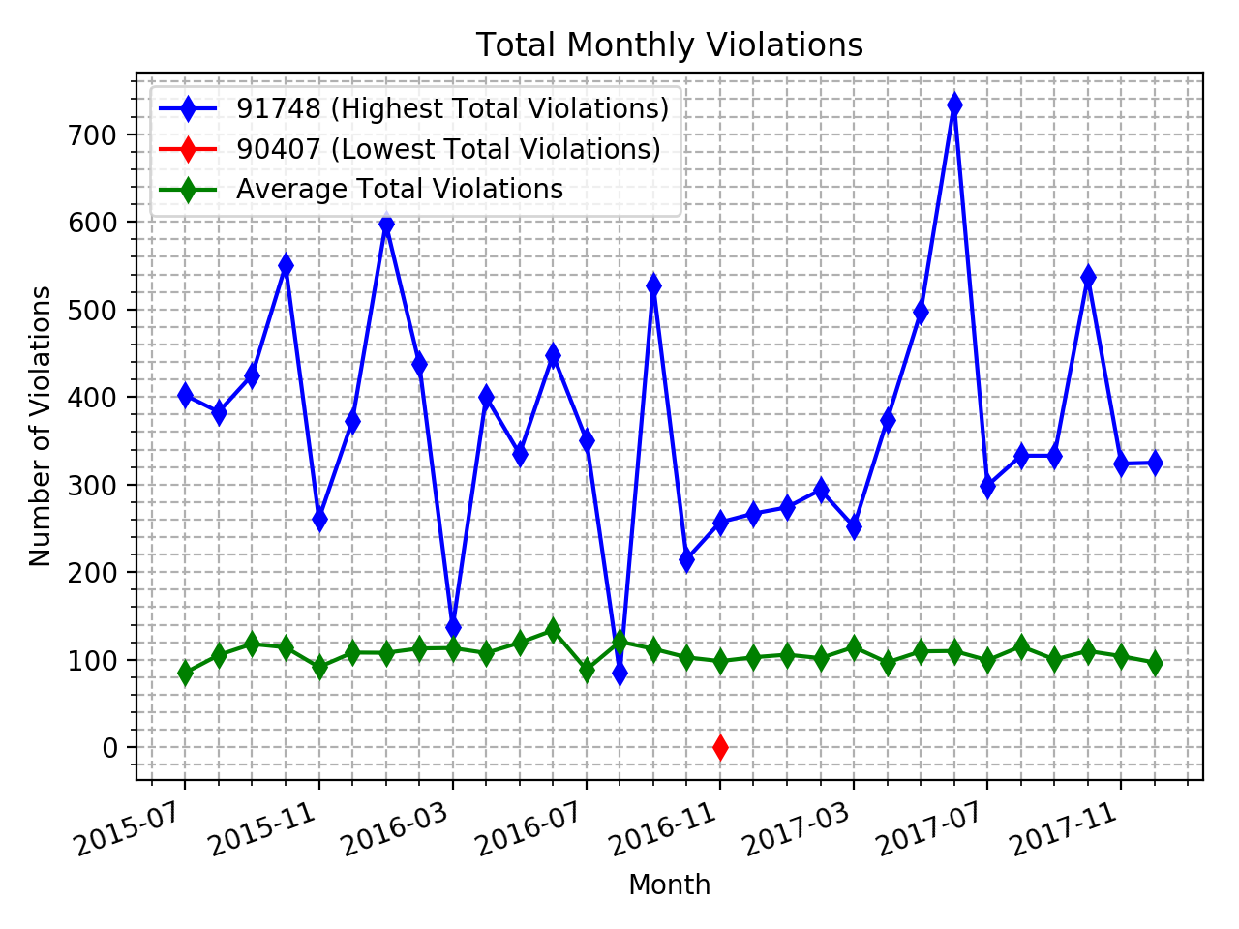

Figure 1

When reading the data some inspections contained zip codes with 4 extra numbers, such as 90401-1501. The 4 extra numbers were only used if the facility was in a complex such as a mall or apartment block. It was determined to only use the first 5 numbers of the zip code to create this report as they determine what area the facility is in.

The database was then also queried for the average monthly total violations committed by every McDonald’s and Burger King store. The results as shown in Figure 2 show that McDonald’s consistently commit more violations per month than Burger King. However, Burger King is far more inconsistent than McDonald’s with a range of committing less than 3 to 5 violations a month on average. Whereas McDonald’s is consistently committing between 4 and 5 violations a month on average. The results show that Burger King can be considered a safer place to buy fast food than McDonald’s as they commit less violations on average.

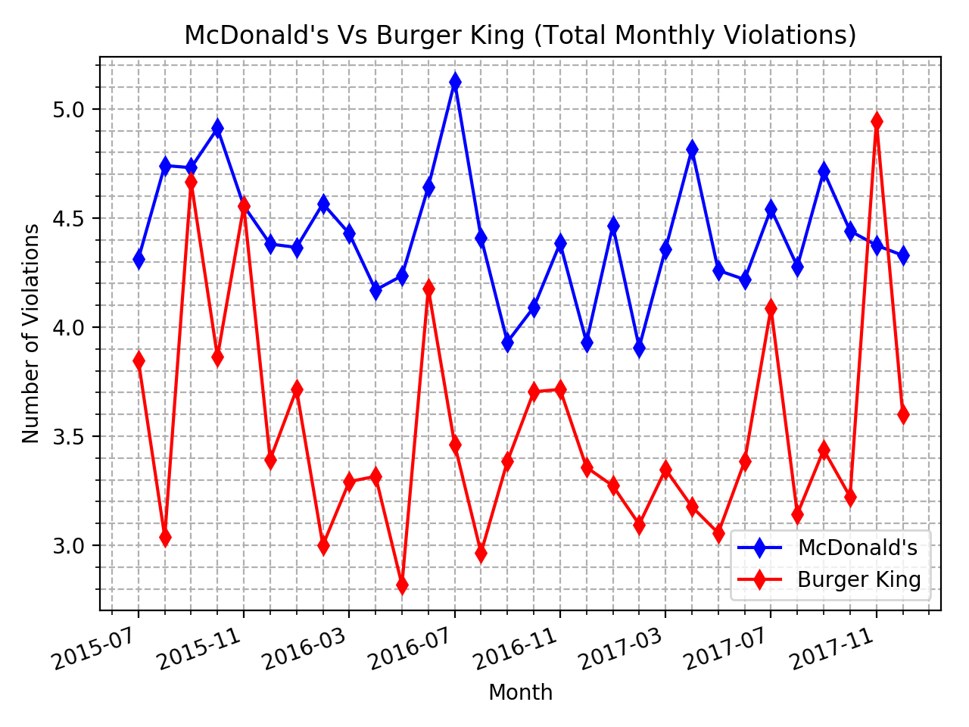Figure 2

# 